Hyperion 2026 Plan (Condensed)
Please note: This is a streamlined version of our full planning document. Some details have been shortened or summarised — for the complete breakdown, refer to the original document.

Hardware

Problems identified in 2025
The hardware problems that were identified in 2025 are:
- Wheels didn't have enough grip when robots ran at high speeds (surging) therefore, slid on the field.
- Light sensor board was positioned in a way that it could have shorted when against the aluminium plates, and it was too low to the ground, where it scraped the painted white line at States.
- Mirror was unreliable due to the reflective foil, leading to unwanted reflections
- Robot relied on momentum and couldn’t score from a distance, resulting in wasted battery when surging and missed scores due to overshooting.
- Robot could not always keep possession of the ball and had to rely on angling the robot while moving to guide the ball towards the goal

Background research

Wheels – (Luke)
Table () compares the previously used single Omnidirectional wheel to a new Double Omnidirectional wheel.
Key factors | Type of Wheel
 | Single Omni-Directional Wheel | Double Omni-Directional Wheel
Load Capacity | Lower because rollers handle more stress individually, reducing overall load capacity. | Higher because the load is distributed across more rollers, allowing greater support
Traction & Stability | Offers less traction, which can lead to slipping on smooth surfaces. | Provides greater traction and smoother, more controlled movement.
Size | Narrow and compact, suitable for smaller robots or limited spaces. | Wider area, offering better balance and surface contact.
Durability | Rollers wear out faster due to concentrated stress. | Increased durability because the rollers share the load and wear more evenly.
Maintenance | More affordable but may require frequent roller replacement. | Higher initial cost but lower maintenance frequency over time.

The double omni wheel provides extra grip and stability to the robot while having higher durability for long use.

Out Avoidance – (Luke)
Due to the larger wheels, table () compares different shapes of light sensor boards to find the best solution for our problem.
Key Factors | Shape of Board
 | Quad perimeter sections and inner ring  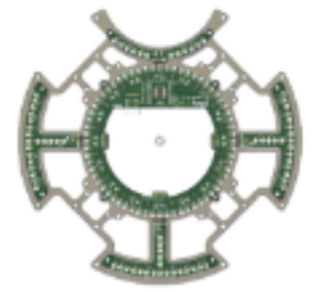 | Outside Wheel Ring  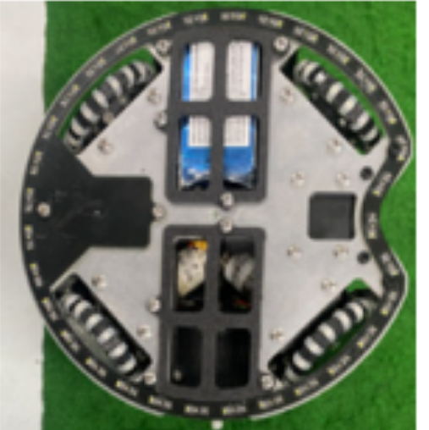 | Inside wheel Ring  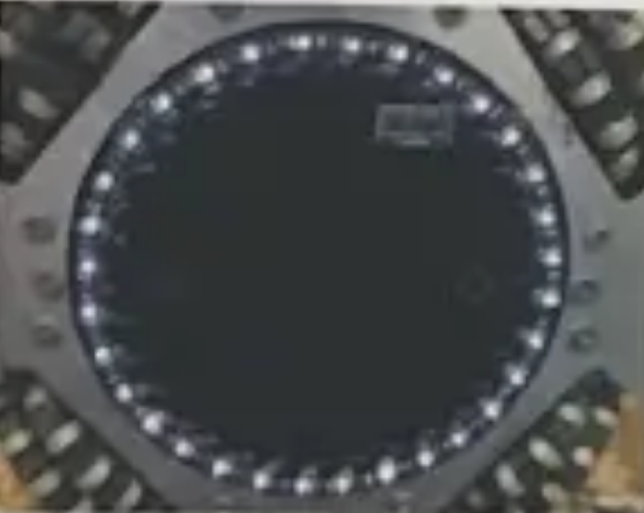

Mirror – (Luke)

Capture system – (Matthew)
The capture zone

Requirements/Restrictions - (Matthew)
Multiple requirements have to be considered in the design process. These requirements are:

Solutions – (Matthew)

Electrical

Problems identified in 2025
The electrical problems that were identified in 2025 are:
- Motor controllers were not easily accessible due to camera
- Camera and Teensy ports were inaccessible due to Bluetooth module
- TSSP’s took too many pins on 1 Teensy 4.1
- LSB routing not optimal
- International communication module not considered in design before ordering PCBs & got reset when logic line switched off
- TSSPs gave inaccurate strength readings
- Robot positioning inaccurate due to mirror/camera limitations

Background research

Positioning on the field
Based on past international teams, ultrasonic sensors were used to detect the walls for positioning.
Model | Min/Max Distance | Resolution | Accuracy | Connection Method | Refresh rate | Cost (AUD)
DRFRobot-URM09-Ultrasonic-Distance Sensor | 2cm – 500cm | 1cm | 1% | I²C | 20ms
HC-SR04-Ultrasonic-Module-Distance-Measuring-Sensor | 2cm – 400 cm | 3mm | 3mm | Digital | 50 –100ms

Requirements/Restrictions
Multiple requirements must be considered in the design process. These requirements are:

Solutions

Software

Problem Breakdown
The robot has multiple components incorporated into its design. To combine these components and their uses, an extensive code must be utilised.
Physical Components of our code include Bluetooth, Camera (Teensy & OpenMV Side), Drive System, Light System, TSSP System, Voltage Divider, Compass, Kicker (Mechanics & Strategy), Dribbler (Mechanics & Strategy).
Other Components of our code include the Movement Strategy (Defender & Attacker), PID, and Timers.
These must all be intricately connected in our main.cpp, and must have their respective libraries.

Background Research
A variety of background research was conducted, as can be seen in the following appendices:
- TSSP System
The ball’s direction can be detected using either vision or infrared systems. A vision-based system like the OpenMV H7 camera can identify the orange ball and coloured goals to estimate position but may lose sight if the ball is obscured. Alternatively, TSSP sensors can detect the ball’s infrared light, offering more reliable and consistent tracking even with visual obstructions.
- Attack Movement Strategy
Background research for this can be seen in Table 1.1 (Appendix).
- Defender Movement Strategy
Background research for this can be seen in Table 1.2 (Appendix).
- Light System
To stay within the field, a robot must detect the white boundary lines, which can be done using light sensors like phototransistors paired with LEDs. These sensors measure reflected light intensity, with white surfaces reflecting more than darker ones. Arranging the sensors and LEDs in a ring around the robot provides 360° coverage, allowing it to detect the line’s presence and direction for corrective movement. This can be achieved by using the clustering method this allows for groups/clusters of sensor to be marked as detecti
ng the line, this allows for the centre of the cluster to be converted into a direction.
- Camera System
OpenMV software uses Python to process images from an OpenMV camera, identifying the ball and goals by color through methods like blob tracking. Data is sent via UART in this order: two start packets, then X and Y coordinates for the yellow goal, blue goal, and ball. The receiving system will use serial functions to read these values and applies equations to calculate each object’s angle and distance:
$$Angle:f\left(x,y\right)=(90-\tan^{-1}{\frac{y}{x})}mod 360$$
$$Distance:f\left(x,y\right)=\sqrt{x^{2}{+y}^{2}}$$
- Bluetooth System
Background Research for this can be seen in Table 1.3 (Appendix).
- Kicker System
To use the kicker effectively, it will only activate when it aids in scoring. A timer prevents excessive firing, and a voltage check ensures sufficient charge before activation. The kicker is triggered by writing HIGH to a digital pin but only when the robot has ball possession (detected via a light gate), is aimed at the goal, and is on the opponent’s side of the field.
- Dribbler System
The robot maintains ball control by detecting when the ball enters its capture zone using ball strength sensors and activating a motor to pull it in. A simple state-based system manages this, keeping the motor off while idle and spinning it forward when the ball is detected, with timing control, current monitoring, and signal filtering improving reliability. For gameplay, the robot can use ball snatching, which is quick but risks losing control, or orbit and dribble, which provides smoother, more accurate positioning and strategic shooting, though slightly slower.

Specification of Requirements
In order for our robot’s software to be ‘successful’, the following criterion must be met.
- Ball Detection and Tracking
  - Accurately detect the orange ball using TSSP sensors (Lightweight) or the OpenMV Camera (Open)- (or both).
  - Track ball position in real-time and calculate angle and distance relative to the robot.
  - Maintain ball possession using the dribbler system.
- Movement and Navigation
  - Implement attack and defender strategies according to the game state.
  - Use motor movement calculations to ensure precise movement and smooth direction changes.
  - Detect and respond to white boundary lines using the light sensor system to stay inside the field.
  - Must be able to score from each neutral point on the field.
- Goal Detection
  - Use OpenMV camera to detect yellow and blue goals.
  - Calculate angle and distance to opponent’s goal for accurate targeting.
- Kicker System
  - Only activate the kicker is in possession of the ball, aimed at the opponent’s goal, and on the opponent’s side of the field.
  - Implement a timer and voltage check to prevent premature or excessive kicking.
- Dribbler System
  - Activate dribbler motor when the ball enters the capture zone.
  - Aide in the possession and accuracy of goal scoring.
- Communication
  - Send and receive data via Bluetooth for debugging or external control.
  - Receive position data from the OpenMV camera via UART in the correct packet format.
- System Integration
  - Ensure all components (camera, TSSP, dribbler, kicker, light sensors, PID, timers, motors) operate in coordination.
  - Maintain real-time performance for gameplay decisions.
- Reliability Requirements
  - All software routines must handle unexpected data safely (e.g. Noise, Division by Zero in angle calculations).

Brainstorm, Evaluate and Choose Solutions
Ball Detection:
- Options: TSSP sensors only, OpenMV camera only, or hybrid system.
- Camera: Accurate angle/distance and goal detection but can fail if ball is obscured.
- TSSP: Lightweight, reliable infrared detection, works even if ball is partially hidden.
- Chosen solution: TSSP’s (Lightweight), Camera (Open)
Movement Strategy - Attack
- Options: Cases, Exponential/Quadratic, PID
- Chosen solution: Exponential/Quadratic as it has a smooth curvature, medium processing demand, stable and predictable.
Boundary Detection
Dribbler & Kicker Activation
  - The dribbler and kicker will be used to maintain possession, only being triggered when a certain amount of power is available, and when the ball is close enough.
  - Adds timers, current monitoring, and signal filtering for reliability.
Communication
- Bluetooth will be used for switching communication and advanced strategy.
- UART to receive camera position data in correct packet format.
Integration & Final Solution
- All components integrated via main.cpp: camera, TSSP, dribbler, kicker, light sensors, PID, timers, and motors.
- Software loop:
  - Read sensors → calculate angle/distance → decide strategy → control motors & actuators.
Ultimate Robot Function:
- Detects and tracks the ball reliably.
- Maintains possession using dribbler.
- Navigates field safely and avoids boundaries.
- Scores efficiently with the kicker.
- Adapts between attacking and defending strategies.
- Operates reliably in real-time under game conditions.

Appendix

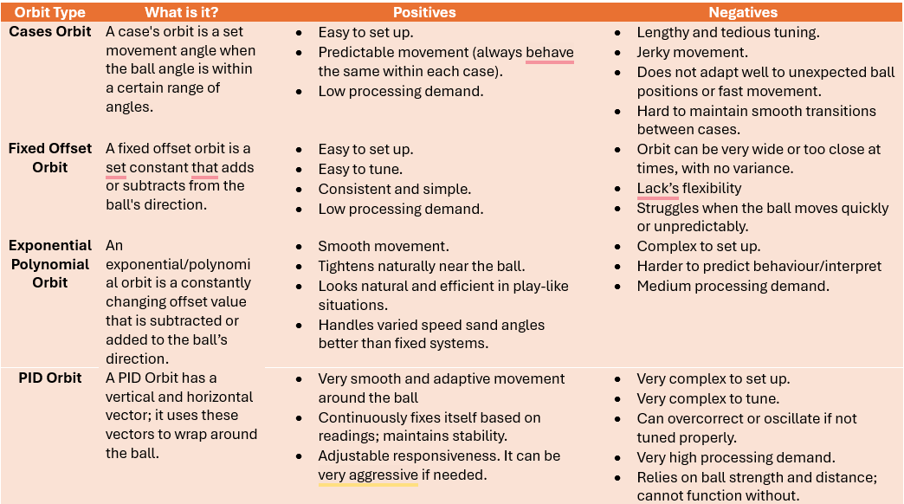
Table 1.1 – Orbit Compare and Contrast

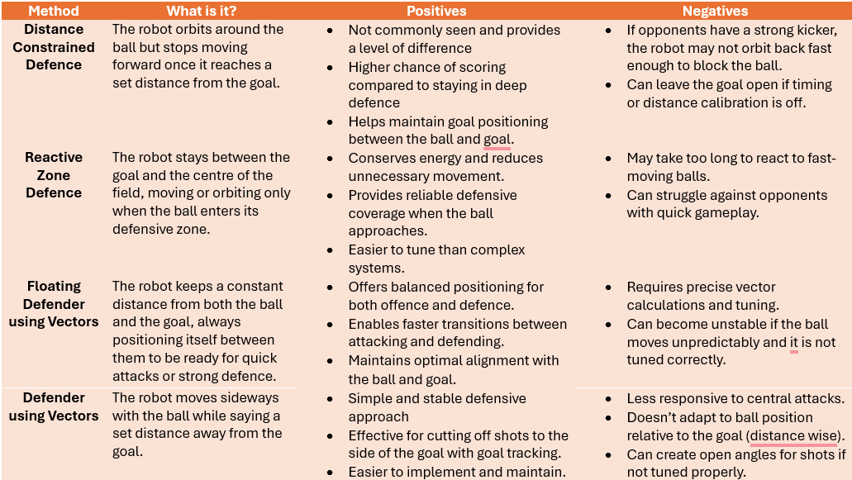
Table 1.2 – Defence Strategy Compare and Contrast

Table 1.3 – Bluetooth Strategy Compare and Contrast
